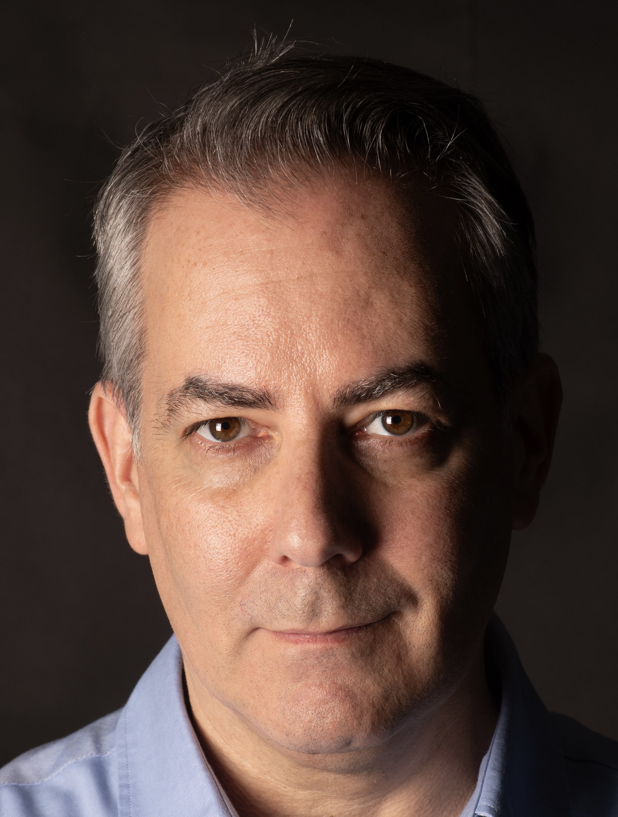
CERI FOSTER
Representation Argentina/Brazil: Casa Urde
Union: Actores Argentina

Height: 5’11”/180cm Hair: Silver/Dark Brown Eyes: Brown

Selected Film and Television

SENNA British Journalist Netflix/ Vicente Amorim
OPERATION FINALE Israeli Guard Netflix/ Chris Weitz
LA FLOR Rosenthal (VO) El Pampero Cine/ Mariano Llinás
DEATH OF A REPTILIAN Reptilian INCAA/ Mauro Andrizzi
ÉPICA British Officer INCAA/ Sandra Gugliotta
COVERT AFFAIRS FBI Agent USA Network/ Stephan Kay
ONE OF THE HOLLYWOOD TEN Comedian Alibi Films/ Karl Francis
THE TERRITORIES Journalist Ancine/ Ivan Granovsky
THE QUEEN’S CANTONESE Robert Ricecake Productions/ Wayne Yung

Selected Voice Over Work

CREST RADIO
PARAMOUNT PICTURES TV
BACARDI RADIO
TANG TV
YPF TV
DALLAS PETS ALIVE RADIO
COCA COLA TV
SEDAL TV
AUDIBLE eBOOK

Selected Theatre Work

DAISY MILLER Butler UK Tour/ Christopher Moran
DUCHESS OF MALFI Malatesta Cochrane Theatre/ Di Trevis
MARY STUART Amyas Paulet Cochrane Theatre/ Annie Tyson

Training

Visiting Student Amor De Dios Flamenco School, Madrid, Spain
BA Hons Drama Centre London, Central St. Martins, London, UK
Visiting Student Company Pierre Debauche Theater Du Jour, Agen, France

Skills

Full Driving licence, Fluent Spanish, Conversational French, Basic Portuguese, Intermediate Guitar, Intermediate Bass, Fencing

